Cyclomatic Complexity dari Method adduser Class Database

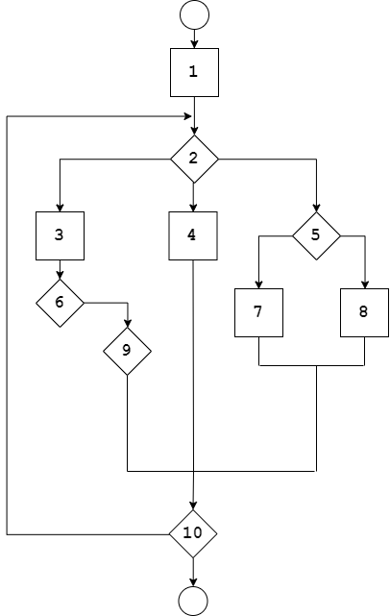

V(G) =

Independent Paths

Path 1 : 1,2,3,6,9,10

Path 2 : 1,2.4.10

Path 3 : 1,2,5,7,10

Path 4 : 1,2,5,8,10

Path 5 : 1,2,5,8,10,1,2,3,6,9,10